GQRX Installation and Guide for Raspberry Pi

GQRX is an SDR interface that can be installed on Raspberry Pi. This is especially useful on RPi given its portability. This will be needed in order to perform the car key fob replay attack. The purpose of this tutorial is to provide information about how an SDR can be used, and how people can use it for malicious purposes. This will provide a basic understanding on radio frequency listening/recording so that security personnel can better defend against such attacks. Under no circumstance should this tutorial be used for anything malicious or illegal!

Method 1: Installing using the GUI on RPi (Best for RPi 4)
- Click on RPi menu button and go to Preferences > Add / Remove Software
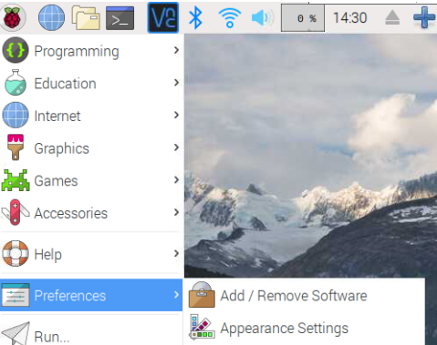

- On the search box, search for GQRX.
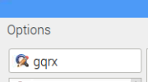

- A package should be found called “Software Defined Radio Receiver.” Select it, and click apply. You will be asked to input your RPi password in order to download. Wait for installation.

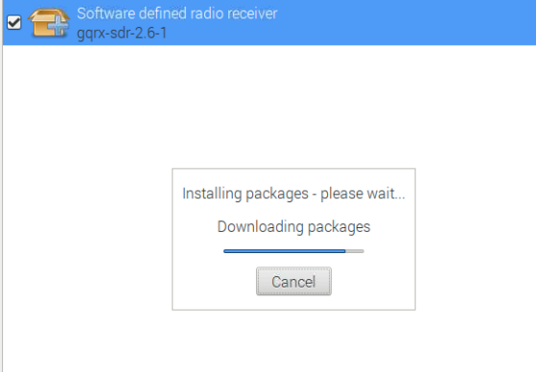

- Reboot your RPi.
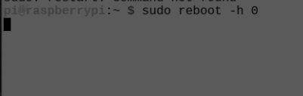

- GQRX should appear under the Internet tab, you can now click it and launch the software.
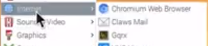

Method 2: Installing using the GQRX website (Best on RPi 3)

- On your RPi, Go to GQRX.dk. Go to Downloads and click on GQRX SDR 2.11 for Raspberry Pi 3.
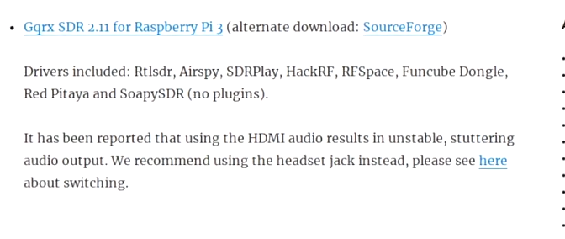
- Go to your Downloads and open the Zipped file.

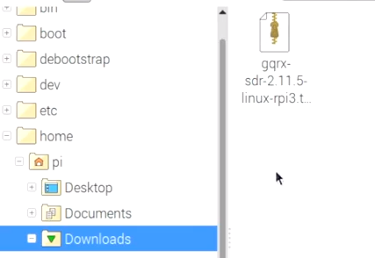

- Drag and drop the contents to the same Downloads folder where the original zipped file is in.
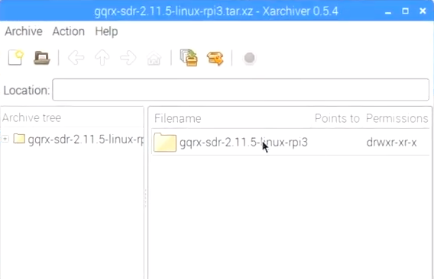

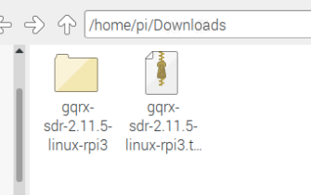

- Open the readme file and follow the instructions. Step 5 below is a guide on the readme file.
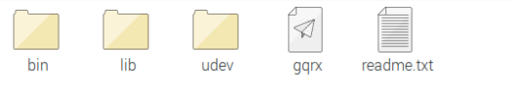

- Follow the instructions on the readme file.

sudo apt install gnuradio libvolk1-bin libusb-1.0-0 gr-iqbal
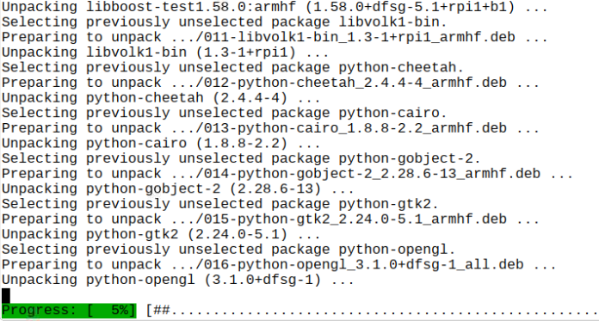

sudo apt install qt5-default libqt5svg5 libportaudio2
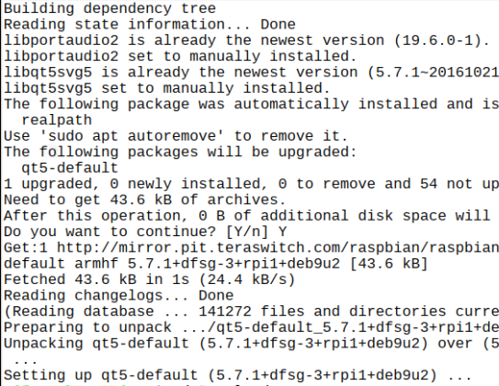

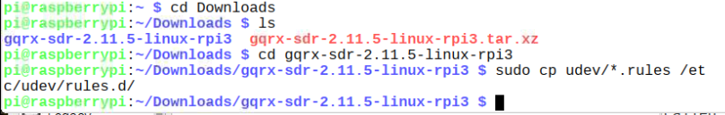

- Run the following command to ensure GQRX is working. (Must be under the GQRX directory)

- An I/O menu will appear where a SDR needs to be selected. In this case, the device is “Realtek RTL2838UHIDR”
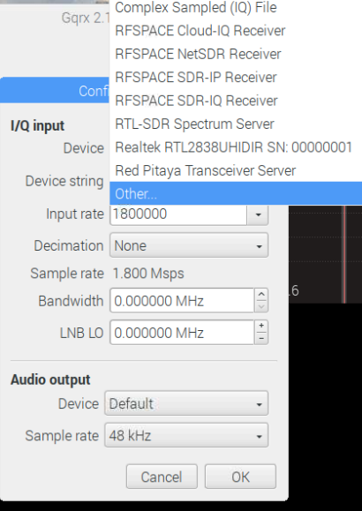

- GQRX should now run and if everything is working correctly, you should be picking up frequencies.
